**Connecting your Chromebook to WiFi:**

1. Click on the WiFi icon on the bottom right of the screen. 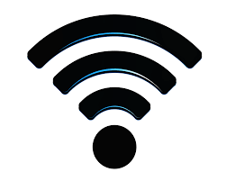
   1. If you don’t see the icon, you may need to sign out of the person who was last using the computer by clicking the dropdown next to their name and clicking “sign out”
2. Click on “not connected” to search for available networks
3. Click on your network from the list
4. Enter your password associated with your personal WiFi network
5. You now should be connected!

**Signing in to the Chromebook:**

1. Click “add a person” on the bottom left of the screen
2. The “email” to be entered is your child’s student ID
   1. This number begins with 45
3. Click next
4. The password to be entered on the next screen is your child’s birthdate with the two digit month, two digit day, and four digit year. Example: 01052007 (January 5, 2007)

By this point in the year, all children should know their login information, as it is used daily. If they have forgotten their 45 number, you can obtain it from your child’s FOCUS account.

If you need assistance with any of the activities in the packets or with technology issues, please reach out to your child’s teacher via phone, Remind, Dojo, or email (please do not use social media). They will be available Mon.-Fri. during normal school hours to answer questions and help as needed.

**\*\*Please remember, these computers are to be used for Distance Learning activities ONLY. ALL activity on the computer is stored under the student’s log in information, even if it is done outside of the district WiFi system. Please remind your child of the purpose of the device and allow them to use them only for educational activities. Thank you!!**